# SEO: Web Page Optimization

If website access was granted, we implemented the changes on your behalf. However, if we were not granted access, please follow the steps below to make the recommended changes:

1. Review the recommended changes to your **Title**, **Meta Description**, **H1 tag and Alt Image Tag**. The definitions of these terms can be referenced below.
2. Send the edits to your web developer for implementation.

Definitions

* **Title:** The Title is the first line within a search result and appears on the web page tab.
* **H1 Tag:** The H1 Tag is the primary heading on a web page. Because it offers an overview of the content that follows, the H1 Tag should be located near the top of the page.
* **Meta Description:** The Meta Description is a website synopsis that is displayed within a search result.
* **Alt Image Tag:** The Alt Image Tag is the text description of an image or graphic on a web page.

Recommendations

The recommendations below will be made to <http://www.passengerpicks.com/>.

* **Implement Title and Meta Tags**

Title and Meta Tags are important because they help search engines understand what your website is about.

* + **Recommended Title:** <title>Restaurant Discounts in the Cayman Islands</title>
  + **Recommended Meta Description**: <meta name= "description" content="Passenger Picks can help you find restaurant discounts in the Cayman Islands. Visit our website or contact us to learn more today!"/>
* **Create Heading Tags**

Creating a heading within an <h1> tag makes it easier for search engines to confirm that your headings and the content of your page are aligned. Creating an H2 tag can add more specific information to your H1 tag, or to the overall page. It is ideal to have ONE h1 tag per page. Please change any extra h1 tags as appropriate.

* + **Recommended Heading**: <h1>Restaurant Discounts for the Cayman Islands</h1>
* **Add Keyword(s) to Alt Image Tag**

The Alt Image Tag is important because it helps search engines understand the content of a page. As such, it is recommended that web page has a permanent image that is relevant to the page and keywords.

* + **Recommended Alt Image Tag:** Add a permanent image that is relevant to the page and keywords. The image should have appropriate image alt text that includes the keywords **(restaurant discounts Cayman Island).**
* Search engines like Google love great web copy. This means that the more unique copy on each of your web pages, the better. We recommend having at least 250-400 words of relevant, keyword-rich copy that includes your keywords **(restaurant discounts Cayman Island)**.

Additional explanation of the recommended **Title**, **Meta Description**, **H1 Tag, and Alt Image Tag** changes are found on page 2.

**Recommended Title:**

Restaurant Discounts in the Cayman Islands

Google Organic Search Listing

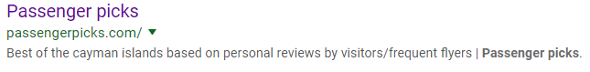

**Recommended Description:**

Passenger Picks can help you find restaurant discounts in the Cayman Islands. Visit our website or contact us to learn more today!

**Title**

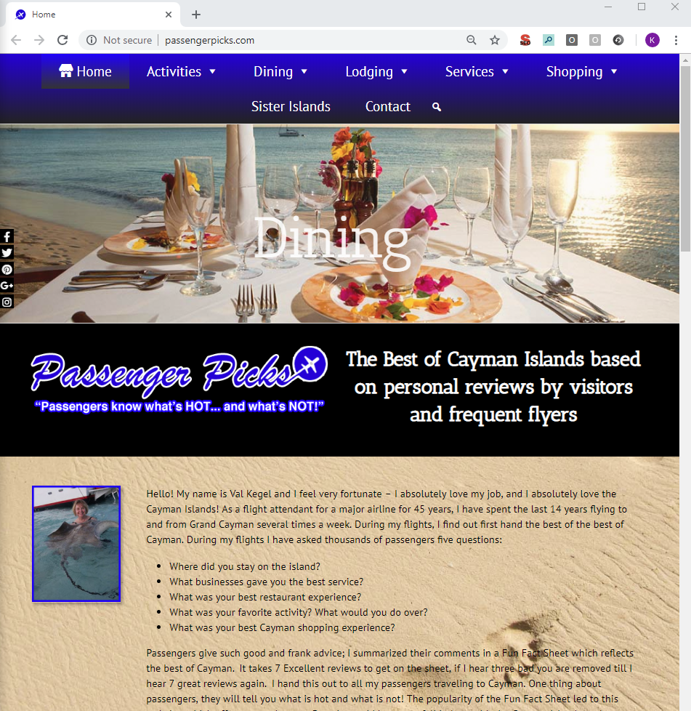

**H1**